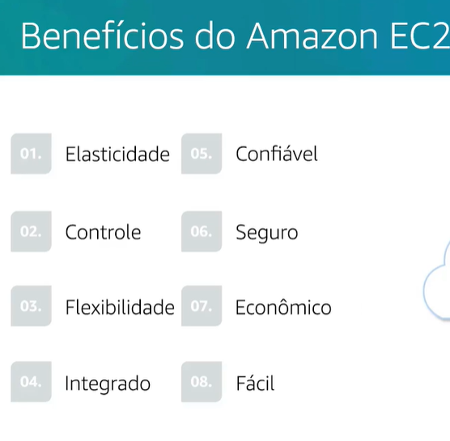

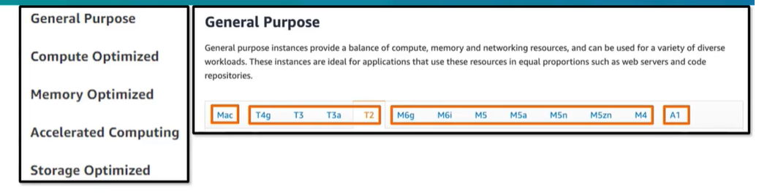

<https://calculator.aws/#/>

<https://aws.amazon.com/pt/premiumsupport/plans/>

<https://aws.amazon.com/pt/about-aws/global-infrastructure/>

[https://aws.amazon.com/pt/products/?aws-products-all.sort-by=item.additionalFields.productNameLowercase&aws-products-all.sort-order=asc&awsf.re%3AInvent=*all&awsf.Free%20Tier%20Type=*all&awsf.tech-category=*all](https://aws.amazon.com/pt/products/?aws-products-all.sort-by=item.additionalFields.productNameLowercase&aws-products-all.sort-order=asc&awsf.re%3AInvent=*all&awsf.Free%20Tier%20Type=*all&awsf.tech-category=*all)

<https://d1.awsstatic.com/training-and-certification/docs-cloud-practitioner/AWS_Certified_Cloud_Practitioner_Exam_Guide_v2.1.pdf>

<https://aws.amazon.com/pt/architecture/well-architected/?wa-lens-whitepapers.sort-by=item.additionalFields.sortDate&wa-lens-whitepapers.sort-order=desc&wa-guidance-whitepapers.sort-by=item.additionalFields.sortDate&wa-guidance-whitepapers.sort-order=desc>

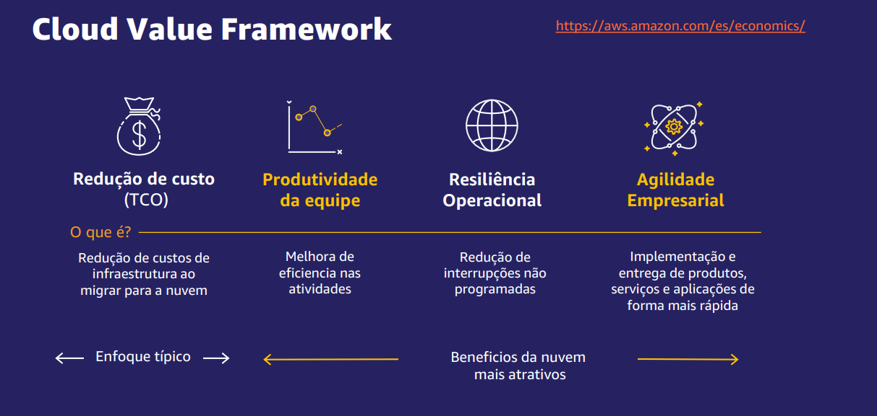

<https://aws.amazon.com/pt/developer/language/python/?nc1=f_dr>

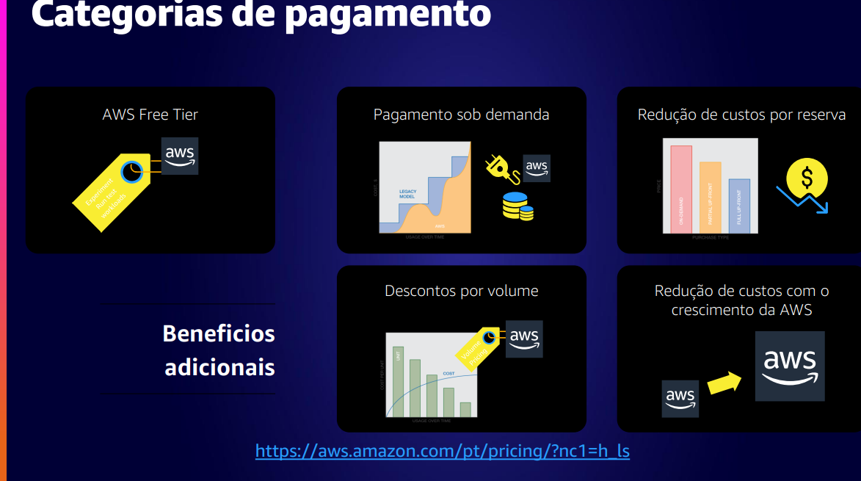

[https://aws.amazon.com/pt/pricing/?nc1=h_ls&aws-products-pricing.sort-by=item.additionalFields.productNameLowercase&aws-products-pricing.sort-order=asc&awsf.Free%20Tier%20Type=*all&awsf.tech-category=*all](https://aws.amazon.com/pt/pricing/?nc1=h_ls&aws-products-pricing.sort-by=item.additionalFields.productNameLowercase&aws-products-pricing.sort-order=asc&awsf.Free%20Tier%20Type=*all&awsf.tech-category=*all)

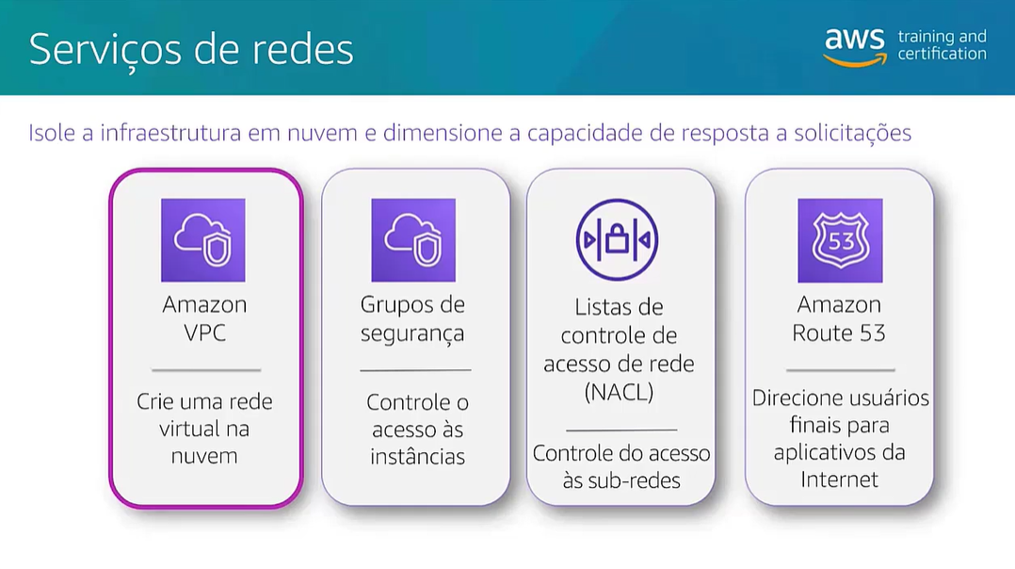

<https://aws.amazon.com/pt/visualstudiocode/>

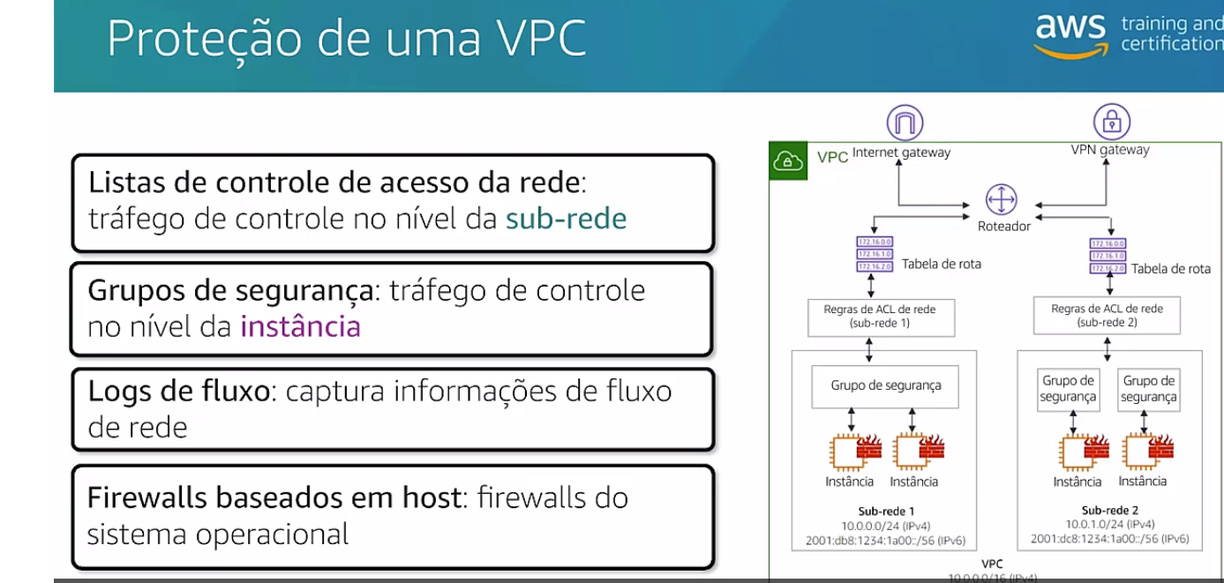

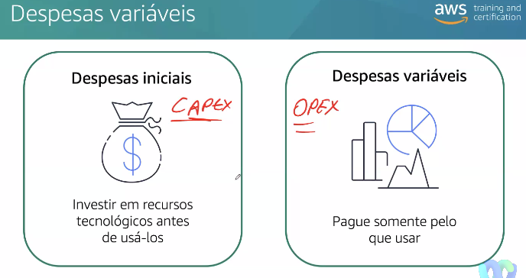

**Recursos adicionais**

Revise esses recursos para saber mais sobre os conceitos que foram explorados no módulo 3.

* [Infraestrutura global](https://aws.amazon.com/about-aws/global-infrastructure/)
* [Mapa interativo da infraestrutura global da AWS](https://www.infrastructure.aws/)
* [Regiões e Zonas de Disponibilidade](https://aws.amazon.com/about-aws/global-infrastructure/regions_az)
* [Blog de redes e entrega de conteúdo da AWS](https://aws.amazon.com/blogs/networking-and-content-delivery/)
* [Ferramentas de criação na AWS](https://aws.amazon.com/tools/)
* [Histórias de clientes da AWS: entrega de conteúdo](https://aws.amazon.com/solutions/case-studies/?customer-references-cards.sort-by=item.additionalFields.publishedDate&customer-references-cards.sort-order=desc&awsf.customer-references-location=*all&awsf.customer-references-segment=*all&awsf.customer-references-product=product%23vpc%7Cproduct%23api-gateway%7Cproduct%23cloudfront%7Cproduct%23route53%7Cproduct%23directconnect%7Cproduct%23elb&awsf.customer-references-category=category%23content-delivery)

**Recursos adicionais**

Para saber mais sobre os conceitos explorados no módulo 1, revise estes recursos.

* [Glossário da AWS](https://docs.aws.amazon.com/general/latest/gr/glos-chap.html)
* [Whitepaper: Visão geral da Amazon Web Services](https://d0.awsstatic.com/whitepapers/aws-overview.pdf)
* [AWS Fundamentals: visão geral](https://aws.amazon.com/getting-started/fundamentals-overview/)
* [O que é computação em nuvem?](https://aws.amazon.com/what-is-cloud-computing/)
* [Tipos de computação em nuvem](https://aws.amazon.com/types-of-cloud-computing/)
* [Computação em nuvem com a AWS](https://aws.amazon.com/what-is-aws/)

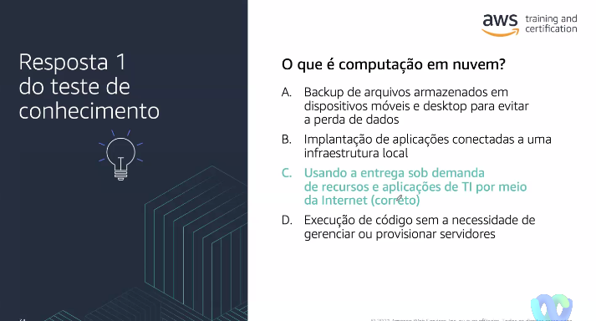

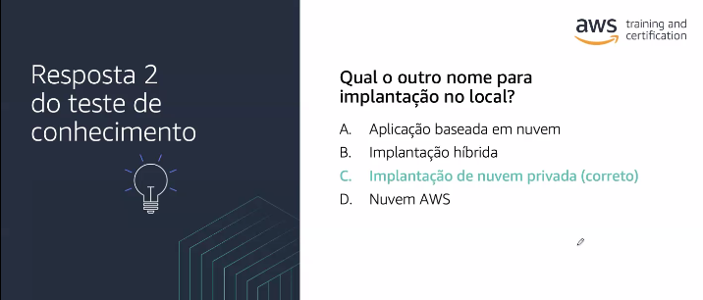

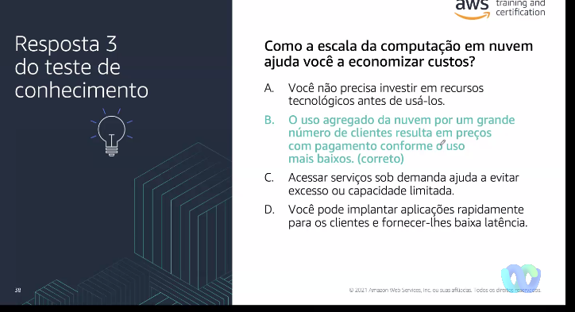

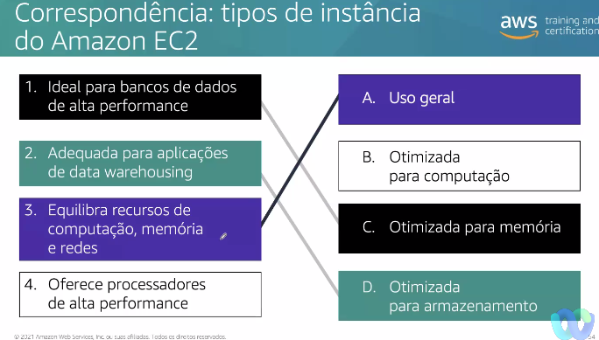

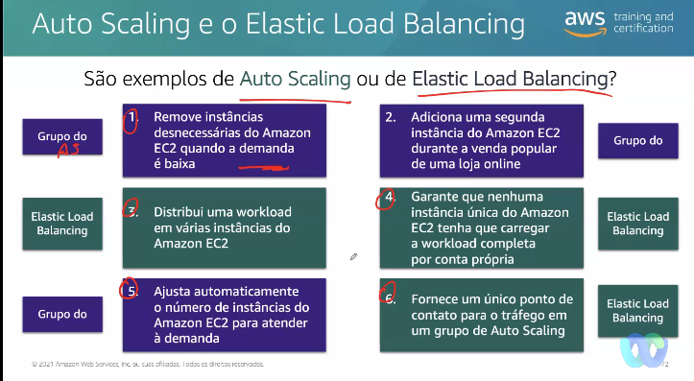

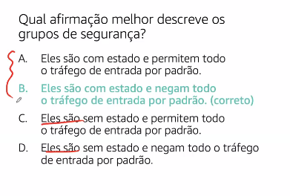

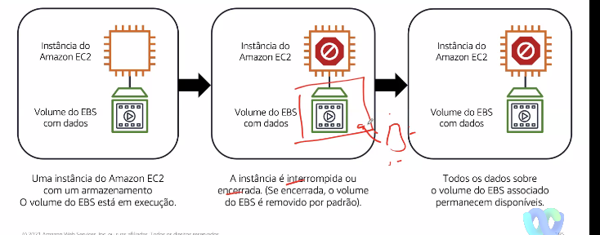

tem planos individuais ou em grupo. No individual 29USD mes, mas lembre que você passa a ter acesso a um ambiente real de laboratório - https://aws.amazon.com/training/digital/

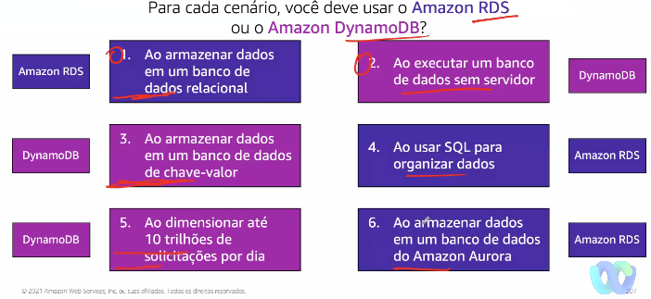

<https://aws.amazon.com/es/ec2/instance-types/>

**Recursos adicionais**

Para saber mais sobre os conceitos que foram explorados no módulo 4, revise estes recursos.

* [Redes e entrega de conteúdo na AWS](https://aws.amazon.com/products/networking)
* [Blog de redes e entrega de conteúdo](https://aws.amazon.com/blogs/networking-and-content-delivery/)
* [Amazon Virtual Private Cloud](https://aws.amazon.com/vpc)
* [O que é o Amazon VPC?](https://docs.aws.amazon.com/vpc/latest/userguide/what-is-amazon-vpc.html)
* [Como o Amazon VPC funciona](https://docs.aws.amazon.com/vpc/latest/userguide/how-it-works.html)